AREA 3 CONVENTION & CONTEST

MAY 3-5, 2019
SYRACUSE, NY

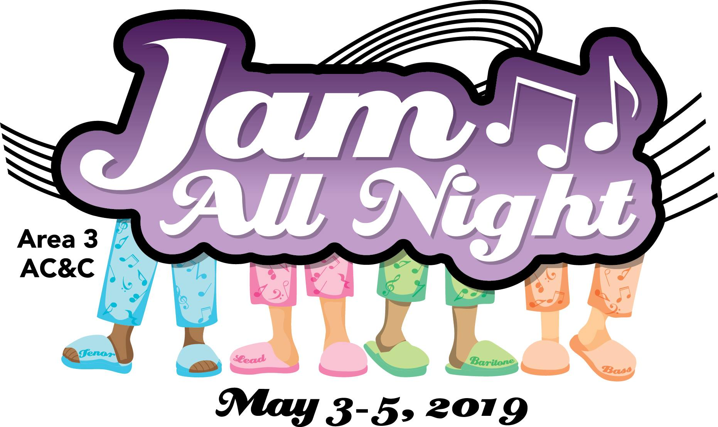

AREA 3’s ACCT (Area Convention & Contest Team)

and Hostess Chapter, BELLA NOVA,

Welcomes You To:

“JAM ALL NIGHT”

This 1st mailing provides members with important information. Please read fully for details:

*Page 2 = Hotel Information

*Page 2 = Contest Registration

*Page 3 = Contestant General Information

*Page 4 = TENTATIVE Weekend Schedule & MBHA Information

*Page 5 = Area Chorus / Quarus / Family Song Information

*Page 6 = Hostess Chapter Information

*Page 7 = Moonglow / Program Ads

More details will follow in the 2nd mailing in early April. Questions? Please email ACCT Dorene at: acct@area3harmony.org

----------------------------------------------------------------------------------------------------------------------

AC&C 2019 HOUSING
Please complete & return an email copy, if mailing a hard copy, it must be postmarked by MARCH 15, 2019
to: Denise Michaelsen, 1669 Erie Station Road, Henrietta, NY 14467
[email: facilities@area3harmony.org]
Hotel: Holiday Inn Syracuse-Liverpool & Staybridge Suites, 441 Electronics Parkway, Liverpool, NY 13088. Room costs are: $129.00 [single/double or triple/quad]
**NOTE: Staybridge Suites guests already have their room prices as these rooms were booked in December. There are STILL A FEW SUITES LEFT. Please hurry to securely register for those if interested; free breakfast is included!
Individual reservations will NOT be accepted. All choruses will receive an emailed 2019 AC&C Housing form, prefilled with the people in their chorus that have already booked suites. Return that ONE completed Housing Form with the rest of the people in your group. Please, no handwritten forms; they can be very hard to read. Each chapter/quartet contact must provide a contact email for questions. A list of occupants in each room is required; be sure to indicate any special needs. The form allows for a chapter credit card so, if you are paying with a Chapter credit card, this card is needed ONLY to hold the reservation. Reserved cards are imprinted at check in.

NYS choruses may submit a Tax Exempt ST-119 Form (Denise can email that to your chorus Treasurer if needed), along with their Housing form. ALL rooms under the exempt status for that chorus need to be paid by a chorus credit card or cash. A debit card attached to a chorus checking account or cashier’s check is recommended. (NO tax exempt status for individuals.)

Parking on-site at the Holiday Inn Syracuse-Liverpool is FREE. There is an on-site restaurant and excellent amenities such as an indoor swimming pool, fitness room, & complimentary high speed internet access. It’s also attached to the Staybridge Suites Hotel, where many members have booked suites. There are some retail stores and food services nearby as well!
Please, ALL reservations are to include the following information. Thank you!
- Name[s] for all occupants of each room, also include room type.
(single/double, trip/quad). This is a NON-SMOKING HOTEL.
- Credit card type to be used for payment, including number & expiration date – this is required only for the purpose of ‘holding’ the reservation…
- Arrival Date & Departure Date [check in is 3PM ~ check out is by 12 noon]
=================================================================================

AC&C 2019 REGISTRATION [AEP]

Contest Site: Holiday Inn Syracuse-Liverpool – CONVENTION CENTER [attached]
As last year, our contest location is THE SAME as our HOUSING venue!! Just as we do at IC&C, we are conducting all AC&C 2019 events under one roof! The Convention Center is part of the Holiday Inn!
Please complete & return an email copy, if mailing a hard copy, it must be postmarked by MARCH 15, 2019
To: Michelle Buckenmeyer, 59 Autumn Chapel Way, Rochester, NY 14624 [parliamentarian@area3harmony.org]
Full AEP for AC&C 2019 is $105.00
Non-Performing AEP costs $84.00
Youth AEP will cost $89.00 [again covered by STEVE HEGADORN GRANT]
**AEP prices include Judges Equalization Fee from Harmony Inc. & continue to include $37 MoonGlow dinner!

General Admission tickets can be purchased by Area 3 members that are not performing, family members, friends, or guests for $15.00 per event. REMEMBER: AEPs are transferable, not refundable. All choruses / associates must complete this form whether or not you are competing.
*PLEASE be certain all registered names are spelled so that AEP badges are accurate. Complete the names in alphabetical order for each member attending, & list the appropriate AEP price. Also include known guest names and money for any tickets being purchased [$15] or dinners [$37]. Note: This allows guest seating with the chorus they register with!
*PLEASE return the Registration Form as an MS Word file. This way, the names and chorus/quartet you are associated with are submitted accurately, and they will be printed on the AEPs exactly as entered on the form! Mail a copy of the form with ONE CHECK as payment, all fees included, to Michelle. All choruses/members are highly encouraged to return their paid AEP Registration Forms as soon as possible!!
*NOTE: Reminder, receipt order of AEP/Registration determines priority MoonGlow seating!*
-2-

AC&C GENERAL CONTESTANT INFORMATION: It's time for all contestants [chorus & quartets] to complete and send in their Contest Entry Forms. Please download the forms (HAR-061 or HAR-063) from the Harmony Inc. website, Members Only section; complete and send with the correct entry fee to the Corporate Office. The mailing address is on Page 2 of the form. A copy of the Contest Entry form is sent electronically from the Corporate Office to Nicola Stevens, Area Contest and Judging Chair (ACJC), in order to complete the draws for order of appearance.

Contest Entry forms must be postmarked no later than March 4, 2019, in order to be a part of the initial draw for the Order of Appearance for either the Quartet or Chorus Contest. If you miss this date, a late fee will be assessed and you will sing first in the applicable contest. In order to compete, your late entry must be postmarked no later than April 3, 2019.

The JUDGING PANEL has been assigned:
Chairman of Judges: Sue Novosad (Area 1)
Associate Chairman of Judges: George Joslyn (BHS)
Music: Kathy Greason (Area 1), Cary Burns (BHS)
Performance: Sandi Wright (Area 4), Mark Kettner (BHS)
Singing: D Dyer (Area 2), Jen Wheaton Forest (Area 4)
If you have any questions with regard to either the Chorus or Quartet contest, please contact ACJC Nicola Stevens at a3jc@harmonyinc.org
Please Note: There will be NO stage curtain. Each chorus package starts when the director signals the emcee for the introduction. Quartet packages begin when the emcee introduces each quartet.
Chorus Photo: CHORUS photos will be taken on the stage immediately after your chorus has finished singing. Please plan your photo pose ahead of time, and be prepared to go into that pose immediately after taking your applause. [Quartet photos will still be in a separate room prior to the warm-up room].
Quartet Heads-up: Please note that the Quartet Contest time listed below is tentative. We may have to start earlier depending on the number of quartets that might be competing. We will not know this until all entry forms have been submitted. Please consider coming Thursday night if possible, so you can enjoy contest day without being rushed!
Quartet Heads-up 2: Quartets, please remember that there are no classrooms or warm-up areas, so you will need a hotel room to get ready in. Please don’t leave it until the last minute to figure this out. If possible, try and come Thursday night so you have a room, or see if a chorus member is coming on Thursday who will allow you to use her room.
=================================================================================
VOLUNTEERS
We need lots of help over the weekend in order to put on a successful AC&C. Please consider volunteering for a job on contest weekend. Here is the link to the Sign-Up Genius volunteer sheet.
https://www.signupgenius.com/go/10c0f45aaaa2fa6f85-20192
If you have any questions, please contact Jerri White (whitespirit11@aol.com) – Bella Nova volunteer coordinator, or Nicola Stevens (acjc@area3harmony.org)
-3-

CONTEST STAGE INFORMATION:
As this is a new venue for AC&C, Contest Site details will be provided and updated on the Area website when they become available.
********************************************************************************************
------------------------------------------------------------------------------------------------------------------------------------------
“TENTATIVE” WEEKEND SCHEDULE ~ AC&C May 3-5, 2019
DATE | TIME | SCHEDULE | ROOM/FACILITY
Friday, May 3 | 10 AM – 3.30PM | Registration | Convention Center Foyer
 | 10 AM – 1.30PM | Hospitality | Ballroom East
 | 1:00 PM – 1:30PM | Area Quarus Rehearsal | Cotillion 1
 | 1:30PM – 2PM | Contestant Judges Briefing | Convention Center
 | 2PM – 2:45 PM | Quartet on-stage viewing | Convention Center
 | 3:30 PM - 7:00 PM | Quartet Contest: Area Quarus, Awards & Qualifiers, 1st place sings | Convention Center
 | 6:45 PM – 8.00 PM | Judges Dinner | Onandaga F
 | 8.00 PM – 11.00PM | Evaluations | TBA
Saturday, May 4 | 8AM -10:30 AM | Hospitality | Ballroom East
 | 8:00 AM – 9AM | Chorus on-stage viewing (no singing) | Convention Center
 | 10AM -12 Noon | Registration | Convention Center Foyer
 | 10AM – 10:30AM | Area Chorus Rehearsal | Convention Center
 | 10:30AM – 11AM | Family Chorus Rehearsal | Convention Center
 | 12 Noon – 2:45 PM | Chorus Contest: Area Chorus, Awards & Qualifiers, 1st place sings | Convention Center
 | 3:15 PM – 5:30 PM | Chorus Evaluations | TBA
 | 6:30 PM – 8PM | Cocktails / Dinner | Convention Center
 | 8PM – 10:00PM | MoonGlow | Convention Center
Sunday, May 5 | 9AM – 12:30 PM | Education Classes | TBA
 | 9AM – 11AM | Hospitality | Ballroom East
NOTE: This is a TENTATIVE SCHEDULE ONLY. The Chairman of Judges (COJ) will give the FINAL approval late April, 2019. AGAIN – these times and locations are NOT final!!

********************************************************************************************
========================================================================

Harmony Welcomes Mixed Quartets!

We’re happy to announce that Areas 1, 2, 3, 4, & 6 have opened their arms to include mixed quartets registered with the Mixed Barbershop Harmony Association (MBHA) in this spring’s Area Conventions. These Areas invite mixed quartets of any makeup – MWWW, MMWW, MMMW – to experience the joy of a Harmony convention first hand and to be adjudicated at the AC&C.

For details on how to register with MBHA visit: www.mixedbarbershop.org. Once you are registered with MBHA and your dues are up to date, please contact Nicola Stevens, ACJC (a3jc@harmonyinc.org) for information on how to register your quartet for the Area contest through the Quartet Contest Entry Form (HAR-061). She will send you instructions for filling in this form. All contestants must purchase an All Events Pass [AEP] for the Area Convention & Contest. All Contest Entry Forms are due by March 4th.

For questions or quartets outside of Harmony, Inc., please contact the Area 3 ACJC –
Nicola Stevens: a3jc@harmonyinc.org .

-4-

AREA 3 CHORUS:
Ron Mason is leading our 2019 Area 3 Chorus in song at this year’s AC&C, as the director from Niagara Frontier Chord Authority, our 2018 Area 3 1st Place Champion Chorus. The song is “Orange Colored Sky”, arranged by David Harrington.

Traditionally, the Area Chorus has been made up of 4 singers from each chapter but has not always been limited to that. If you are able to be in the Area 3 Chorus, PLEASE be certain to do your part by LEARNING the song. We will continue with our annual AC&C Saturday morning rehearsal and performance Saturday afternoon at AC&C. Remember that all Area 3 Associate members [in good standing] are also invited to sing in the Area 3 Chorus! The Area 3 Director will send out 4 copies of music and trax to each chorus. Associates and any other member interested in singing may contact Janine Schindler, Area 3 Director at:area3director@harmonyinc.org.

AREA 3 QUARUS:
Our Area 3 Quarus Director for 2019 is Lisa Twitchell, and the song the Quarus will be singing is, “Hey, Soul Sister,” arranged by Elaine Gain. Sheet music and learning trax will be available to registered quartets soon, once you decide that your quartet can learn this song and be with us for the Friday afternoon rehearsal and performance Friday evening at AC&C. Please email the Area 3 Quartet Promotions Coordinator, Lisa Twitchell at: quartets@area3harmony.org for music and trax.

AREA 3 FAMILY CHORUS:
This is an invitation to all Area 3 singers who fall within the FAMILY category to please participate in our Family Chorus at AC&C 2019! This year’s director will be Donna McKay and the song she has chosen is “Let There Be Music”, arranged by Joe Liles. We certainly don’t want to miss anyone who is eligible to enjoy this experience and encourage all members who have a mother, mother-in- law, daughter, daughter-in- law, sister, sister-in- law, aunt, cousin, associate member and/or affiliate male family member that sing in Area 3 – to please join us! It is a very enjoyable and rewarding experience.

Please indicate your interest in participating by emailing Janine Schindler, the Area Director at area3director@harmonyinc.org, and she will send you the music and trax. We’ll continue with our annual AC&C Saturday morning rehearsal and Saturday performance at AC&C so that we may have some time together prior to our performance.

-5-

AC&C 2019 Hostess Chapter, BELLA NOVA, presents:

“JAM ALL NIGHT!”

--------------------------------------------------------------------------------------------------------

Break out your jammies, Area 3! Bella Nova is having a slumber party and you’re invited!

Get ready for a fun weekend with your best girlfriends singing tags, playing games, learning a new dance move and finding out which New Kid on the Block is the right one for you. No one is sleeping at this party, so get comfy, but make sure your pajamas are appropriate.

No girls weekend would be complete without shopping so be sure to check out the Hospitality Room during the convention. No cash? No problem! We’ll take credit cards or Venmo for payment.

We can’t wait to Jam All Night with you!

-6-

~~~~~~~~~~~~~~~~~~~~~~~~~~~~~~~~~~~~~~~~~~~~~~~~~~~~~~~~~~~~~~~~~~~~~~~~~~~~~~~~~~~~~~~~~~~~~~~~~~~~~~~~~~~~~~~~~~~~~~~~~~~~~~~~~~~~~
Reminder -- For the MoonGlow, other than the normal pre-determined awards being presented, only the following will be part of our Saturday evening annual Area 3 AC&C MoonGlow program:
- ALL Choruses -- will perform one song [unless an exemption is requested]
- ALL Area 3 Current Quartet Medalists -- will perform one song
- ALL Area 3 Queen quartets and/or International Chorus Champions -- will perform one song [unless they do not wish to do so]
- Judges -- will perform one song [unless they elect not to do so]

----------------------------------------------------------------------------------------------------------------------------------------------------------------------

-*PROGRAM ADS*: Again, we’re offering choruses/quartets the chance to purchase PROGRAM ADS. Choruses/quartets may wish to send congratulations or good luck wishes to contestants or new members in a program ad!

If you would like to do so, please send the ad copy to our Area 3 Publicity Coordinator, Cait Schadock, pr@area3harmony.org by MARCH 30th- NO LATER!

Send payment to: JANINE SCHINDLER, AREA 3 DIRECTOR,
175 CHELTENHAM ROAD, ROCHESTER, NY 14612

PLEASE ~ your email subject line should read:
ACC2019 PROGRAM AD!

If you have any questions, please be sure to ask Cait!

Program AD Costs --

$15.00 – ¼ page; $25.00 – ½ page; $50.00 – full page

**Look for more information on the Area 3 website at http://www.area3harmony.org

-7-

