AREA 3 CONVENTION & CONTEST
WELCOME TO
SYRACUSE-LIVERPOOL, NY

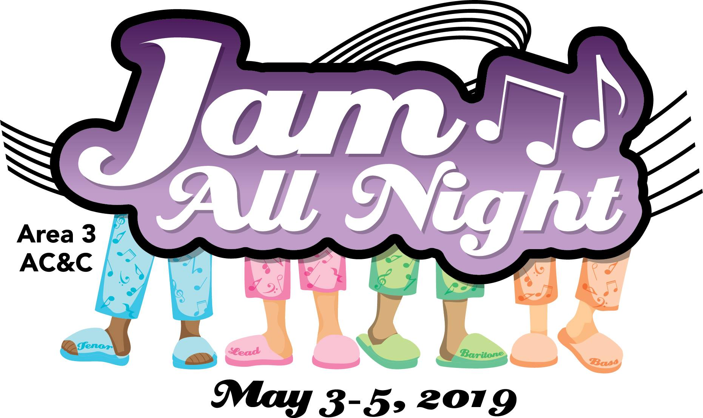

AREA 3’s A.C.C.T. [Area Convention & Contest Team]

and Hostess Chapter, BELLA NOVA,

Included in this 2nd mailing:

====================
General Information Overview
Contest Site Info. & Local Maps
Official Judging Panel
Weekend Schedule
Saturday Banquet Menu
Photography Forms /Video Information
Hostess Chapter / MoonGlow
Education/Craft Class Information

_________________________________________________________________________________________________________________________________

Any Questions? Please email the ACCT General Chair, Dorene Dickerson

at: acct@area3harmony.org

---------------------------------------------------------------------------------------------------------------------------------------
- Parking at the hotel / contest site is FREE. Hotel registration check-in time is 3PM [Staybridge Suites is 4PM] and check-out is 12 NOON [for both]. Room reservation numbers will be assigned by the hotels & sent to the group contact via email before you arrive. Any changes needed AFTER the receipt of these numbers can be made with the hotel directly.

- Registered quartet members are invited to sing in the Area 3 Quarus, directed by Lisa Twitchell. [Please note the rehearsal time for this on the AC&C Weekend Schedule included in this mailing.]

- Representatives [one per part preferably but not mandatory] or any other interested members from each chorus are able to sing our Area 3 Chorus song directed by 2018 Area 3 Champion Chorus Director, Ron Mason. [Please note the rehearsal time for this on the AC&C Weekend Schedule included in this mailing.]

- The Area 3 Family Chorus will be directed by Donna McKay. [Please note the rehearsal time for this on the AC&C Weekend Schedule included in this mailing.]

- Video services will be provided by John Aviste, Daystar Productions; the ordering form is included in this mailing. You can mail this in advance or bring the completed form & payment to the Judges Briefing and give it to the ACCT General Chair, Dorene Dickerson. DVDs will be completed and provided to contestants Sunday morning in the hotel lobby.

---------------------------------------------------------------------------------------------------------------------------Security Issue - Contestants are reminded that Harmony, Inc. will not be responsible for lost or stolen personal property at the Contest site. Leave purses in your room or give to someone in the audience.
NO ITEMS BACKSTAGE PLEASE!!
----------------------------------------------------------------------------------------------------------------------------------------

NO SCENTS MAKE SENSE!!!! Please think of your sisters in song when it comes to perfume or other heavy scents that may bother singers. Remember to PLEASE be courteous and mindful of this concern.

CONTEST ‘ETIQUETTE’
*Enter/Exit auditorium only when doors are officially open
*NO talking/singing along while contestants perform
*NO photography or recording
*NO food in the contest site
******************************************************************************
Holiday Inn Syracuse-Liverpool & Staybridge Suites, 441 Electronics Parkway, Liverpool, NY 13088 – There are SEVERAL ways to locate the hotel. Feel free to ‘Google Map’ the directions to our contest venue: The hotels are located five miles from Hancock International Airport (SYR), two miles from the Regional Transportation Center, and only a five-minute drive to the Destiny USA Mall. Syracuse University & downtown Syracuse is a short five-mile drive, as well as the new Lakeview Amphitheater overlooking Onondaga Lake. The Staybridge Suites are happy to offer a complimentary 24-hour shuttle. The property is located directly across from the NYS Thruway and only one mile from I-81, exit 37.

*******************************************************************************
-2-

Below is a PDF of the closest restaurants to the convention hotels in Syracuse, NY)
WEEKEND SCHEDULE ~ AC&C May 3-5, 2019
DATE | TIME | SCHEDULE | ROOM/FACILITY
Friday, May 3 | 10 AM – 3.30 PM | Registration | Convention Center Foyer
 | 10 AM – 1.30 PM | Hospitality | Ballroom East
 | 1:00 PM – 1:30 PM | Area Quarus Rehearsal | Cotillion 1
 | 1:30 PM – 2 PM | Contestant Judges Briefing | Convention Center
 | 2 PM – 2:45 PM | Quartet on-stage viewing | Convention Center
 | 3:30 PM – 7:00 PM | Quartet Contest: Area Quarus, Awards & Qualifiers, 1st place sings | Convention Center
 | 6:45 PM – 8:00 PM | Judges Dinner | Onondaga F
 | 8.00 PM – 11:00 PM | Evaluations | TBA
Saturday, May 4 | 8 AM – 10:30 AM | Hospitality | Ballroom East
 | 8:00 AM – 9 AM | Chorus on-stage viewing (no singing) | Convention Center
 | 10 AM – 12 Noon | Registration | Convention Center Foyer
 | 10 AM – 10:30 AM | Area Chorus Rehearsal | Convention Center
 | 10:30 AM – 11 AM | Family Chorus Rehearsal | Convention Center
 | 12 Noon – 2:45 PM | Chorus Contest: Area Chorus, Awards & Qualifiers, 1st place sings | Convention Center
 | 3:15 PM – 5:30 PM | Chorus Evaluations | TBA
 | 6:30 PM – 8 PM | Cocktails / Dinner | Convention Center
 | 8 PM – 10:00 PM | MoonGlow | Convention Center
Sunday, May 5 | 9AM – 12:30 PM | Education / Craft Classes | Cotillion 1, 3 & Ballroom West
 | 9AM – 11 AM | Hospitality | Ballroom East

-3-

Below is a PDF of the layout of the Holiday Inn / Convention Center in Syracuse-Liverpool, NY

-4-

A C & C 2 0 1 9 J U D G I N G P A N E L

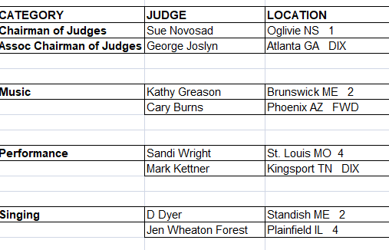

Practice Panel

Angie Dolber [Area 2] – Performance Linda Briggs [Area 2] – COJ

~~~~~~~~~~~~~~~~~~~~~~~~~~~~~~~~~~~~~~~~~~~~~~~~~~~~~~~~~~~~~~~~~~~~~~~~~~~~~~~~~~~~~~~~~~~~~~~~~~~~~~~~~~~~~~~~~~~~~~~~~~~~~~~~~~~~~
=========================================================================================================================
Reminder -- For the MoonGlow, other than the normal pre-determined awards being presented, only the following will be part of our Saturday evening annual Area 3 AC&C MoonGlow program:
- ALL Choruses -- will perform one song [unless an exemption is requested]
- ALL Area 3 Current Quartet Medalists -- will perform one song
- ALL Area 3 Queen quartets and/or International Chorus Champions -- will perform one song [unless they do not wish to do so]
- Judges -- will perform one song [unless, they decline…]

----------------------------------------------------------------------------------------------------------------------------------------------------------------------
-5-

GENERAL CONTEST INFORMATION
Nicola Stevens, Area 3 ACJC
- Contestant Briefing: The briefing is Friday 1:30PM in the convention center. Each quartet must attend, and each chorus must send a representative. Quartet stage awareness will immediately follow the briefing.
- Chorus Stage Awareness: Stage viewing will be held Saturday morning from 8:00-9:00AM. Only FIVE members of each chorus may attend the viewing. There will be no singing.

- Chorus Rehearsal: Each chorus will have an OPTIONAL one-hour rehearsal room available Saturday morning. The rehearsal times are by Order of Appearance:

- 9:00-10:00AM: Heart of Pennsylvania, Crystal Chords, Liberty Belles Chorus, Harmony Falls and Niagara Frontier Chord Authority

- 10:05-11:05AM: Northern Blend Chorus, Reading A Cappella Voices, Rochester Rhapsody and Bella Nova Chorus. *Room assignments will be sent out as part of the schedule to each chorus.

- Evaluations: Times and locations will be announced at contest by the COJ.

- Safety:
  - For safety reasons, scooters will not be allowed to go up the ramp onto the stage. We will have a wheelchair available to transfer into.
  - For safety reasons, no one will be allowed around the back of the risers on the stage. We don’t want anyone tumbling off the back of the stage! Please keep this in mind when sorting out your props.

- Risers: We will be using six, six-foot risers with four steps and a back rail.

- **Reminder: Chorus Photo: CHORUS photos will be taken on the stage IMMEDIATELY AFTER your chorus has finished singing. Please plan your photo pose ahead of time, and be prepared to go into that pose immediately after taking your applause. [Quartet photos will still be in a separate room prior to the warm-up room].
- **Reminder: There will be NO stage curtain. Each chorus package starts when the director signals the Presenter for the introduction. Quartet packages begin when Presenter introduces each quartet.
------------------------------------------------------------------------------------------------------------------------------------------=================================================================================VOLUNTEERS
We need lots of help over the weekend in order to put on a successful AC&C. Please consider volunteering for a job on contest weekend. Here is the link to the Sign-Up Genius volunteer sheet. https://www.signupgenius.com/go/10c0f45aaaa2fa6f85-20192
If you have any questions, please contact Jerri White (whitespirit11@aol.com) – Bella Nova volunteer coordinator, or our ACJC Nicola Stevens (acjc@area3harmony.org)
-6-

Additional Information and Reminders

On Friday, the hotel restaurant will be open for lunch and dinner.

On Saturday, a Grab and Go lunch will be available for purchase outside of the Convention Center from
11am – 3 pm. There will be a variety of sandwiches, salads and beverages. Please consider taking advantage of this offering as it is part of our contract.

Just a reminder that appropriate pajama attire is expected of all members at the
banquet and MoonGlow.
This Photo by Unknown Author is licensed under CC BY-SA-NC

Alcohol is not permitted to be brought into the banquet, MoonGlow, or After Party Rooms unless it is purchased at the Hotel Bar.

Since there is no singing allowed in the hotel rooms, your chorus will be assigned an After Party Room.
You may bring your snacks into the After Party rooms.

After Party Room Assignments:

Ballroom West – Crystal Chords, Harmony Falls, Northern Blend
Cotillion 1 – Heart of Pennsylvania, Reading A Cappella Voices, Rochester Rhapsody
Cotillion 3 – Harmony in Motion, NFCA, Liberty Belles

Associates may go to whatever room they would like. Members may travel to other rooms as well.

Youth Outreach

This year instead of the Basket Auction for Youth Outreach, we will be “passing the hat” during the MoonGlow. Please consider giving a donation of cash or check (made out to Area 3, Harmony, Inc). This money will be designated towards future Youth functions and scholarships to our Harmony Music Camps.
This Photo by Unknown Author is licensed under CC BY-NC

-7-

A C & C 2 0 1 9 B A N Q U E T

Our “JAM ALL NIGHT” Brunch:

Scrambled Eggs, with toppings on the side (cheese, broccoli, mushrooms, crumbled bacon, salsa)[GF, V]
Hash Brown Casserole [GF, V]
Fresh Fruit Salad [GF, V, VE]
Muffins and Danish

Penne Marinara V
Garden salad w/ 2 dressings [GF, V, VE]
Roasted Vegetables with Rice [GF, V, VE]
Carved Ham [GF]
Grilled Chicken with Herb Sauce [GF]
Baked Tilapia [GF]
Coffee, Decaf, Tea [No Dessert]

[GF] = gluten free, [VE] = vegan, [V] = vegetarian

PLEASE NOTE: We are hopeful that any major dietary concerns can be addressed by the variety of foods offered
on our brunch buffet. If that is NOT the case, however, you must be sure to notify the ACCT General-Chair via
email before April 20th to BE CERTAIN that your dietary needs can be addressed. Thank you!
==================================================================================
*The evening’s MoonGlow program will directly follow dinner!!*
=================================================================================
Also please note, Hospitality Room refreshments will be provided by The Holiday Inn for your enjoyment!

Friday, May 3rd = 1PM - Lemonade & Cookies

Saturday, May 4th = 8AM - Coffee, Tea, Decaf, Assorted Muffins, Danish and Cinnamon rolls

-8-

~~~~~~~~~~~~~~~~~~~~~~~~~~~~~~~~~~~~~~~~~~~~~~~~~~~~~~~~~~~~~~~~~~~~~~~~~~~~~~~~~~~~~~~~~~~~~~~~~~~~~~~~~~~~~~~~~~~~~~~~~~~~~~~~~~~~~

2019 Harmony, Inc.
Area 3 Convention and Contests
Video Authorization / Order Form

Your Quartet or Chorus Name: ______________________________________

The above named Quartet or Chorus, hereby authorizes recording of its performances at the 2019 Harmony, Inc. Area 3 Convention and Contests to be held in Liverpool, NY [USA] and authorizes Harmony, Inc. to use any portion of its performances as they deem proper. This may include, but is not limited to, educational materials for internal use and/or commercial recording(s) produced and marketed by Harmony, Inc. We agree that our video, or any part thereof, will not be copied or distributed, without obtaining all applicable permissions, as required by law.

You will receive a data DVD that has your video file on it. You may pick up your disc from 8:00 to 11:00 a.m. Sunday, May 5 in the lobby of the Holiday Inn, Liverpool.

Signed by Quartet contact or Chapter President: __________________________________________________

Please print your name: ___________________________ If a chorus, how many members will sing? ______

Address: ____________________________________________ ____________________________________________________

E-mail address: _____________________________________________ ______________________________________

All performances will be recorded. Whether you purchase a video or not, your quartet or chorus must fill out this form and send it to John Aviste to order your video. Please include a check, made out to Daystar Productions, for $30.00 (US funds) with this form and mail it before April 15, to the address below. You may also order your video Sunday morning, but it is easier and faster to do this in advance.

DVD received by: _____________________________________

Normally I stay in a wide shot for quartets and move in closer for a ballad. I also stay in a wide shot for chorus up tunes, moving in some, on say a ballad. If your chorus or quartet is planning something different or if you have a special request, please describe this below and send me this form before the convention, so that I can add it to my cue sheet.

__________________________________________________________________________________________

__________________________________________________________________________________________

__________________________________________________________________________________________

__________________________________________________________________________________________

~~~~~~~~~~~~~~~~~~~~~~~~~~~~~~~~~~~~~~~~~~~~~~~~~~~~~~~~~~~~~~~~~~~~~~~~~~~~~~~~~~~~~~~~~~~~~~~~~~~~~~~~~~~~~~~~~~~~~~~~~~~~~~~~~~~~~
-9-

------------------------------------------------------------------------------------------------------------------------------------------

Debra Woodard, Photographer
7950 County Road 41, Victor, NY 14564
#585-738-5050 [cell]; email: Marwoodphoto@gmail.com
=================================================================================
AC&C Photo Order Form

Please fill out form and bring it along with your payment at the time of your photo. Price list includes tax. You may pay cash, or make checks payable to: Debra Woodard, Photographer (We do not except credit cards.)

All photos are money back guaranteed. Order will be mailed to picture chairman listed below within two weeks.

5x7’s [1 - 4] = $14.00 each ___ $___________
5x7’s [5 or more] = $12.00 each ___ $___________
8x10’s [1 - 4] = $17.00 each ___ $___________
8x10’s [5 or more] = $14.00 each ___ $___________
Set of 8 wallets = $13.00 set ___ $___________

8x10 Calendar = $15.00 ___ $___________
Ceramic Coffee mug = $25.00 ___ $___________
Water Bottle = $25.00 ___ $___________
Canvas Bag = $20.00 ___ $___________
Beverage Cozy Wrap = $10.00 ___ $___________
8x10 Statuette = $30.00 ___ $___________
Phone cover = $25.00 ___ $___________
*Please indicate phone type: ___________________________

Electronic web image
Quartet $50 [or $10 with a $50 order] $___________
Chorus $150 [or $10 with a $150 order] $___________
--Please add $10.00 shipping & handling for orders under $50 $___________
============
T-O-T-A-L = $___________
============

Chorus or Quartet Name______________________________________________________________
[As you’d like it to appear on your photo…]

Contact Peson______________________________________________________________________

Address___________________________________________________________________________

_________________________________________________Zip______________________________

Email____________________________________________Phone____________________________

------------------------------------------------------------------------------------------------------------------------------------------

-10-

*********************************************************************

AC&C 2019 Hostess Chapter, BELLA NOVA, presents

JAM ALL NIGHT!

--------------------------------------------------------------------------------------------------------
Hello Area 3! Just one month to go until we JAM ALL NIGHT! Bella Nova has been hard at work getting ready for AC&C, and we can’t wait to share it with you.

Start your weekend off right with a stop in the Hospitality Room. We’ll have items for sale including T-shirts, glasses, jewelry, pitch pipe holders and rice bags. No cash? No problem! We’ll take credit cards payments or Venmo
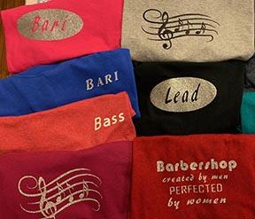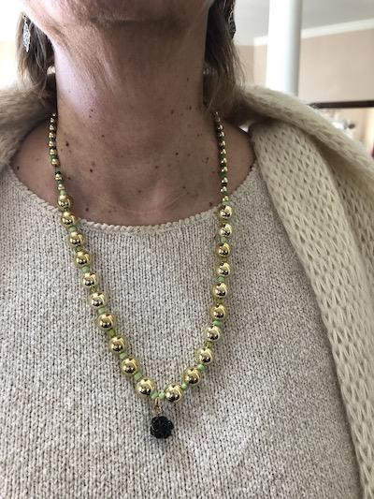

Did your quartet buy matching pajamas for the Moonglow? Be sure to stop by the Selfie Station and get that perfect photo to share on Facebook and show off why Area 3 is The Place to Be!

***DEADLINE EXTENDED***
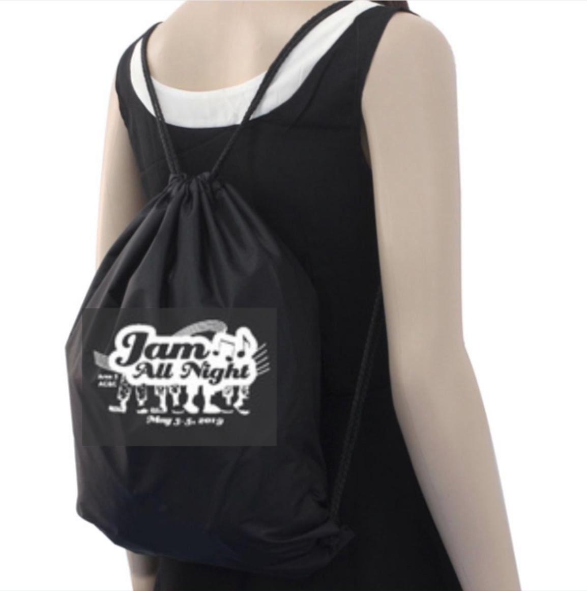
It’s not too late to order your Jam All Night Cinch Bags! You can now order bags through Wednesday, April 10th. Cinch bags are great to hold all your gear while you’re at AC&C. Bags are $10 each, but you must pre-order them. To order, fill out this form: https://goo.gl/forms/nHtpz95YR5YQ4njt2.

If you have any questions about the bags, please contact Kris Adams at kristinabrooke01@gmail.com

Cinch bags can be picked up in the Hospitality Room Convention Center. Cinch bags are perfect to hold all of the goodies that you will want to buy when you get to there!

*********************************************************************
Thank You!!!!
*********************************************************************

-11-

AC&C 2019 EDUCATION CLASSES
Holiday Inn Syracuse-Liverpool Conference Center - Sunday, May 5

Classes are being held in the Ballroom West, Cotillion 1 and Cotillion 3 rooms on the Main Floor of the
Holiday Inn.

9:00 a.m. – 10:00 a.m.
Class 1: What Are Those Music Judges Listening for anyway?? - with Kathy Greason (Certified Music Judge). Well, clearly they aren't paying attention to whether a question ends with a preposition! But they do focus on the barbershop style and elements of the music category as outlined on the scoring forms that they use when listening to contest performances. Through listening to some barbershop performances, this class will explore those elements. Location: Ballroom West

Class 2: Conquering the Aging Voice - with Sandi Wright (Certified Performance Judge). They tell us to use it or lose it, and that is true...well it doesn't get any easier, does it? This class was developed because I am the epitome of an aging voice, but at 67 years old I was still in a top ten quartet. I'll give you the physiological reasons why our voices aren't what they used to be, and I'll also give some advice that works for me. If you are singing along and notice that annoying little wobble, or if you go for a note and it doesn't land in the spot you're aiming for, this class is for you. Location: Cotillion 1

Class 3: Drop and Give Me 25 - with D Dyer (Certified Singing Judge). Learn vocal exercises designed for life-long healthy singing guided by the elements of the singing category: Intonation, Vocal Quality, Unity, Expansion, and Vocal Expression. Location: Cotillion 3

10:10 a.m. – 11:10 a.m.
Class 1: Using Improv to Improve Your Performance - with Katie Taylor (HI Harmony Queen and Director of Northern Blend Chorus, HI 2017 Chorus Champions). Moving the audience with your performance hinges on your ability to emote and share your story. Come see how using theatre improv games can help you tell your story non-verbally and open up your mind to new creative possibilities! Location: Ballroom West

Class 2: Quartet Fixes When There's No Coach in Sight - with Sandi Wright. Okay, so you're in a quartet and something is wrong. How do you fix problems right there at rehearsal? From tuning issues to note problems... Whether it's out of balance or out of synch, these and many more issues are discussed with real-world fixes. High priced coaches are nice, but sometime a DIY approach is best. Learn to be a better quartet with this handy class for all levels. Location: Cotillion 1

Class 3: Alignment Basics - with Jen Wheaton Forest (Certified Singing Judge). The new buzz-word is "alignment" instead of posture. In many ways it is the same, but in some fundamental ways, it is different. This course will discuss the similarities and differences, as well as the "ideal" alignment. Students should be ready to try different body alignments and positions. Location: Cotillion 3

11:20 a.m. – 12:20 p.m.
Class 1: Global Improvements That Everyone Can Do - with Cary Burns (Certified Music Judge). Have you ever wished that you could employ one easy technique that would address many musical issues at once? This class will explore many of these techniques. They are easy to understand and replicate. Have fun while adding to your “bag of tricks.” Location: Ballroom West

Class 2: Performance Category: What SHOULD we be doing? - with Mark Kettner (Certified Performance Judge). Mark describes the methodologies to use, and questions we should be asking as performers to excel in the Performance Category, as compared to the methods of the past. Video examples will be shared to illustrate and support the pillars of great performances. Location: Cotillion 1

Class 3: Breathing Anatomy - with Jen Wheaton Forest. We've all heard the sentences like "breathe from your diaphragm" and "support that sound." But without a true understanding of the mechanisms, it's difficult to know how to use it. Imagine being given the keys to a backhoe and told to use it perfectly without actually having ever seen inside one. This course will cover the structures of the breathing mechanism, including the vocal tract, the lungs, the diaphragm, and other muscles involved in respiration. Get ready to feel those muscles!! Location: Cotillion 3

-12-

